

BLACKJACK PROJECT

DOCUMENTATION



February 3, 2020

Mikhail Goulding

Table of Contents

Program Design 2

Program Description 2

Operating System 2

System Requirements 3

The type and version of programs used 3

Install and setup 4

Install and setup (Continued) 5

Install and setup (Continued 2) 6

How to run 7

Errors 7

Tutorial 8

Starting the game: 8

Playing the game (Part one): 8

Playing the game (Part two): 9

Starting a new round: 9

Scoreboard: 10

Scoreboard: 10

Help: 11

Resetting or exiting the game: 11

Bibliography 12

# Program Design

My source code is saved in the “\Mikhail Goulding Blackjack Project 2020\Blackjack Source Code” folder.

My program consists of a main “Blackjack.sln” file in the “Blackjack Source Code” and a “Blackjack” folder.

The solution file (Blackjack.sln) consists of 1 project called Blackjack.

This project has a file called “Blackjack.cs”. This file contains the main class (Blackjack). The class constructor enables the use of visual forms and then calls the BlackJackForm.

This project has a “Black Jack.cs” file that contains the Blackjack form. (Called BlackJackForm)  
This form contains most of my coding. I split the form into different regions.  
The class has 3 main regions: Variables, Methods and Events.

* The Variables region contains variable and array/arraylist declarations, accessible throughout the class.
* The methods region contains all the methods in the class that I created.
* The event region contains the methods for the events that I control.

See the commenting in my code (Mostly in the “BlackJackForm”) for explanations.

I also have two other forms:

* “How To Play.cs” – This form holds the user tutorial.
* “Scoreboard.cs” – This form shows the scoreboard.

# Program Description

This program is a Blackjack game. Blackjack is a popular card game where the aim of the game is to get a higher score than the dealer without exceeding a value of 21.  
The goal of the program is to entertain the user.

If you have a score of 21, then you have a Blackjack.   
A Blackjack will beat anything the dealer has, unless the dealer also has a Blackjack – in which case the hand is a tie.

Each card has an assigned value:

* Cards 2-9 have the value of the card number.
* 10, Jack, Queen and King has a value of 10.
* The ace can have a value of 1 or 11.

# Operating System

This program will run on Windows Vista or later.   
It is recommended that you use Windows 7 or later.

This program was only tested on Windows 7 and 10.

# System Requirements

Windows Vista or later with .Net Framework version 4.6.1 installed.

1GHz or faster processor

512 MB of RAM

At least 150 MB of available hard disk space available.

A screen resolution of 1366 x 768 or higher is recommended.

# The type and version of programs used

.NET Framework version 4.6.1 is used and required.  
The program will NOT run without .NET Framework 4.6.1 installed.

# Install and setup

I will now show you how to install the game.

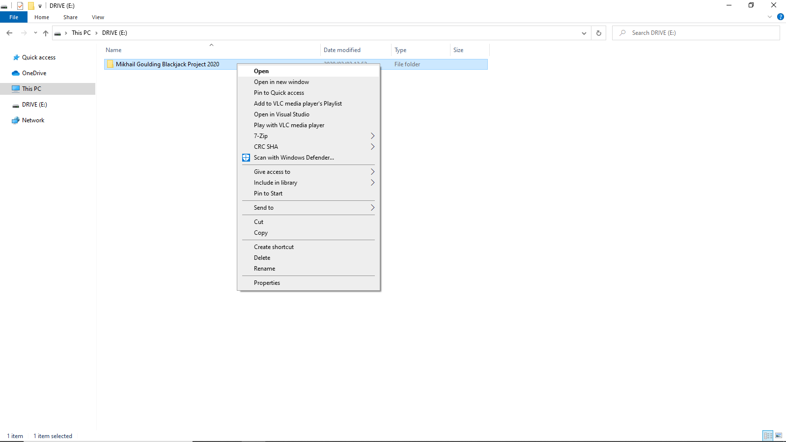In your drive (Possible D: drive), you will see a “Mikhail Goulding Blackjack Project 2020” folder. Double-Click this folder or Right Click->Open.

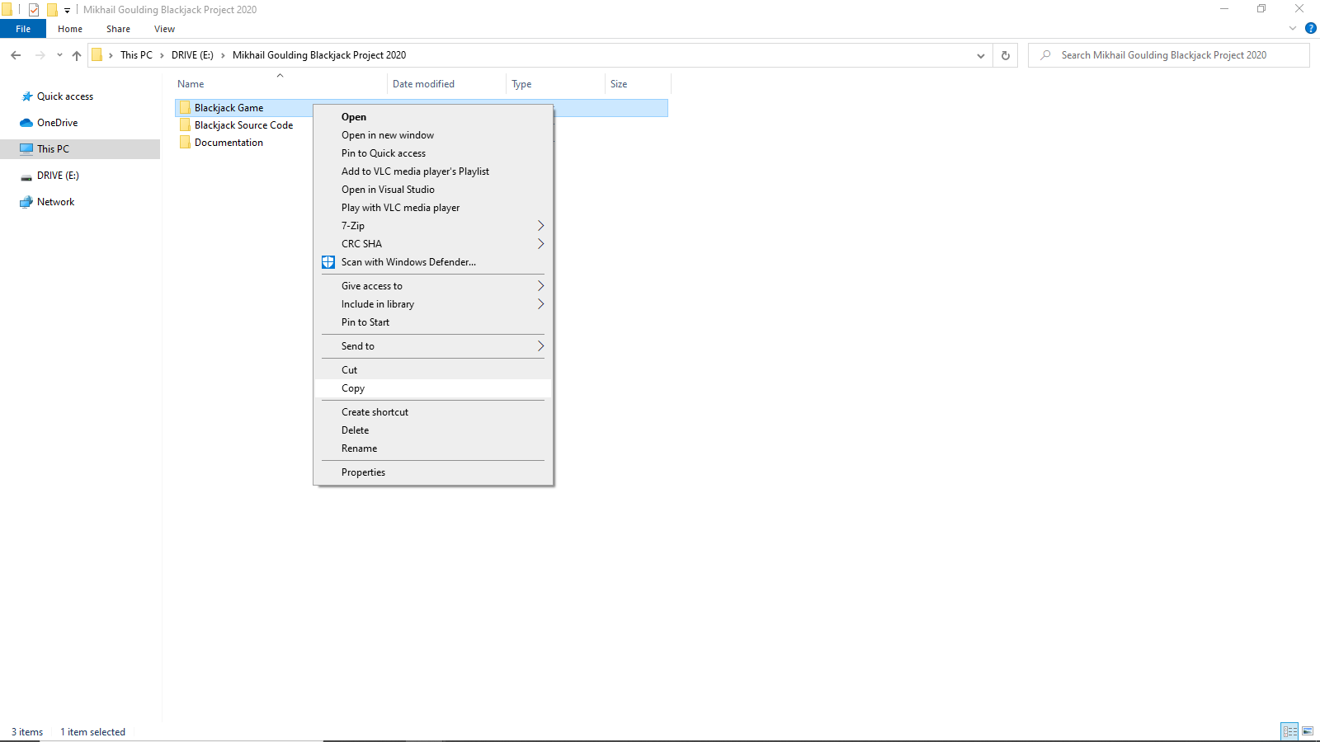Right Click on the “Blackjack Game” folder and click Copy.

## Install and setup (Continued)

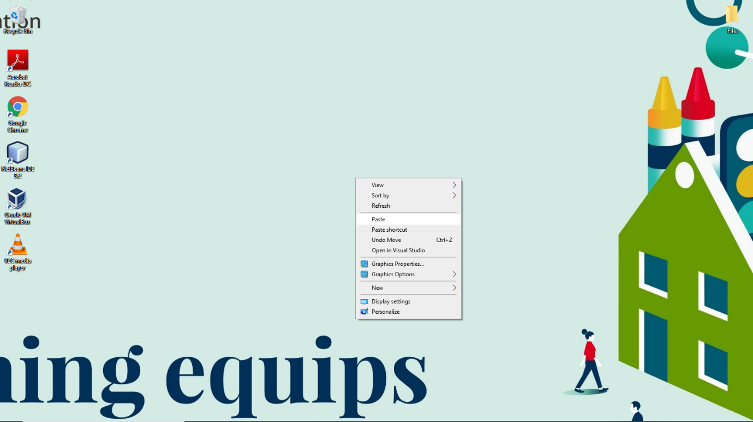Now we are going to copy this folder to the desired location. I will copy the game to my Desktop.  
Right click where you wish to save the game and click paste.

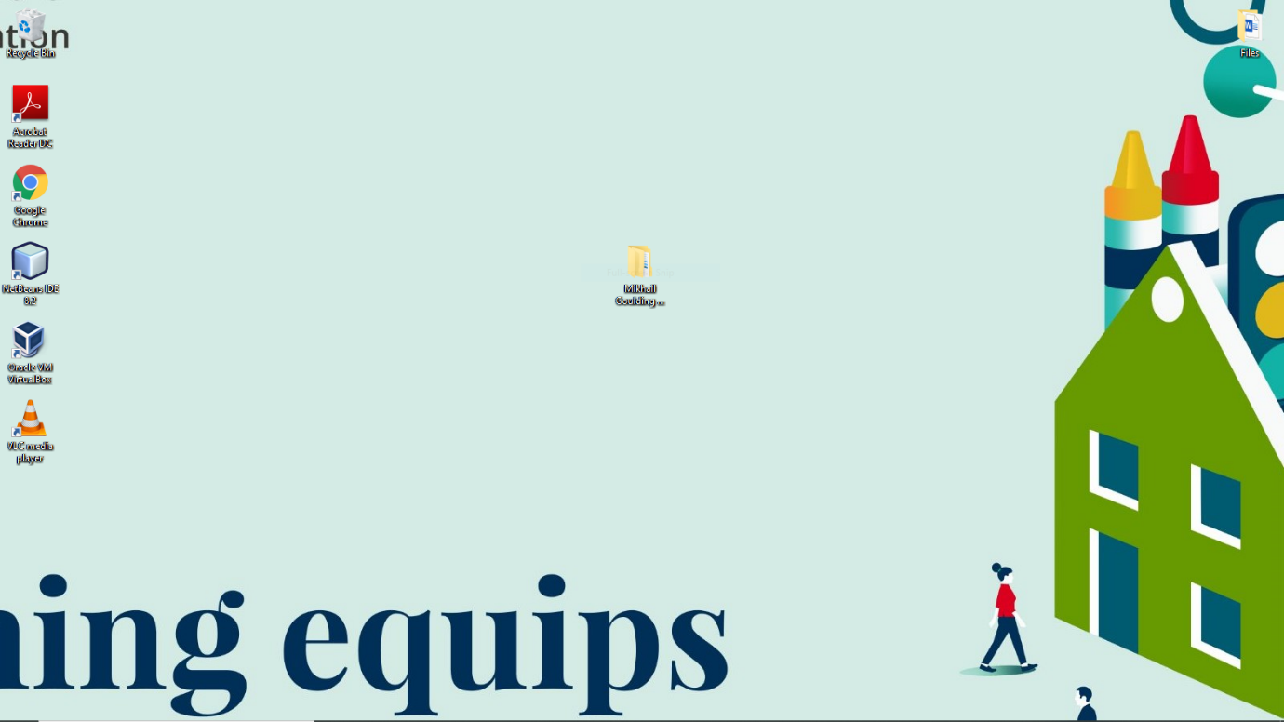The game is now available on your desktop:

## Install and setup (Continued 2)

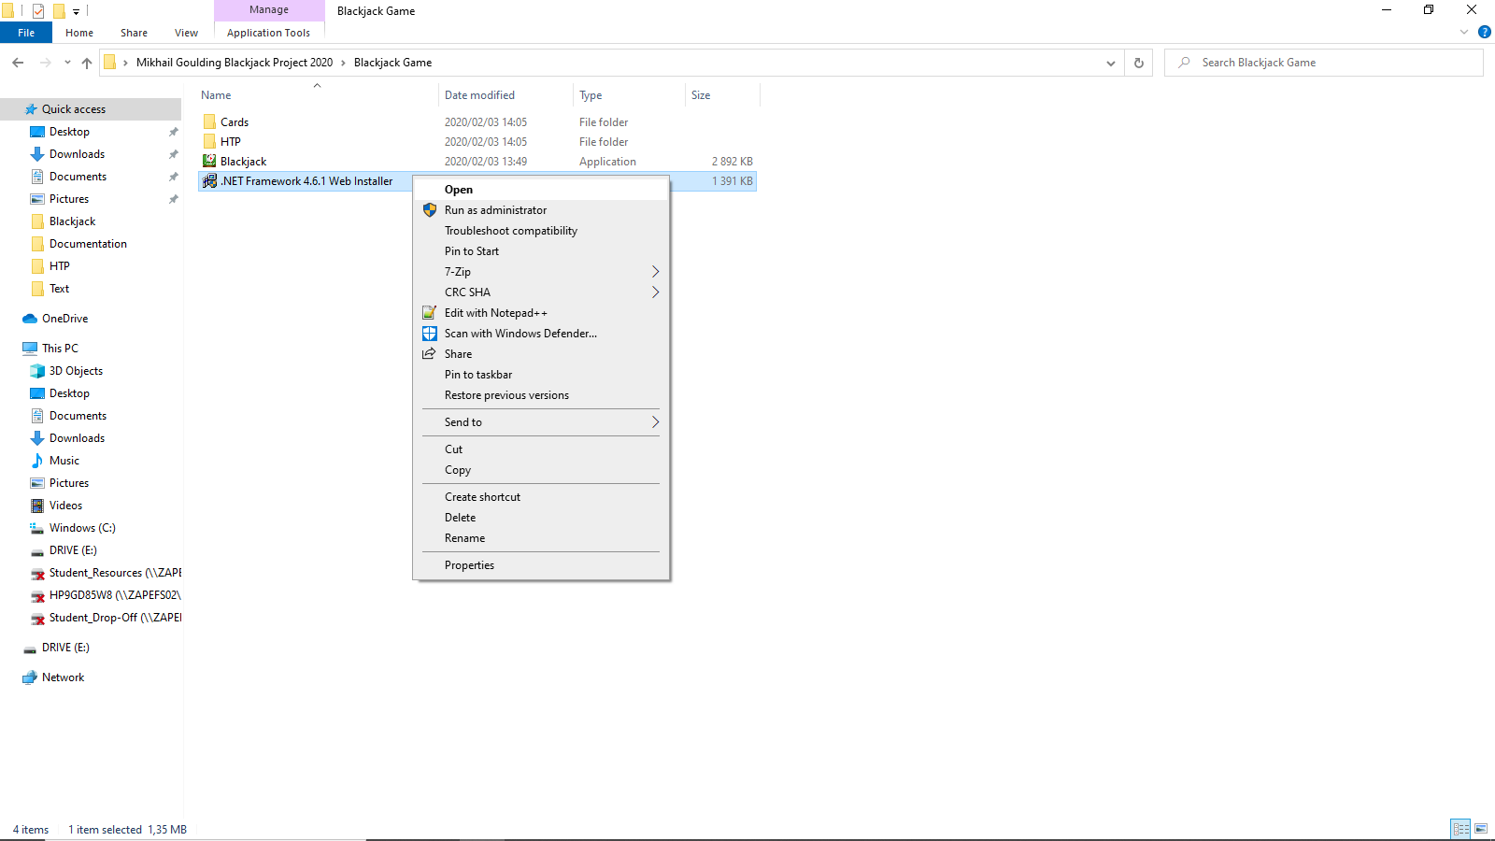Double click or “Right-Click”- Open “.NET Framework 4.6.1 Web Installer.exe” Click Yes when prompted for admin rights. (If you do not have admin on the current account, please install the file on an administrator account) Follow the on-screen instructions when installing the file.

Internet access is required to install this.

This file is the .Net Framework 4.6.1 files required to run the game.  
If the installer says: “The .NET Framework 4.6.1 and this update are already installed on your computer.” then you can close the installation. Otherwise, complete the installation.

# How to run

Once you have installed the .Net Framework, go into the “Blackjack Game” folder that you added to your Desktop. Double click or “Right-Click”- Open the Blackjack.exe file to run the game.

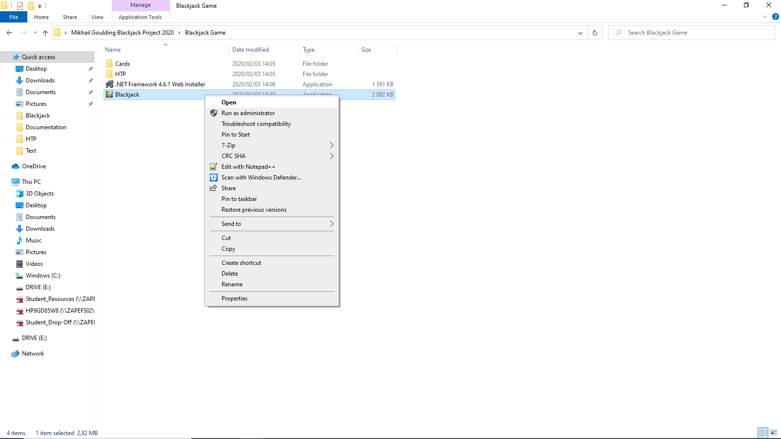If your antivirus runs a scan on the application, let it finish scanning before continuing.

# Errors

* If you receive an error stating that the program cannot be run, then you are missing the .Net 4.6.1 Framework. See Here for .Net installation.  
  If you still receive this error, please check the System Requirements and update your operating system.
* You can receive an error: “File(s) Missing –Card/x.png” where x is a number.  
  This error means that your Cards folder or the file(s) in the folder, is missing.  
  The Cards folder and the Blackjack.exe should be in the same folder.
* 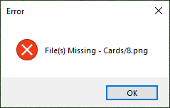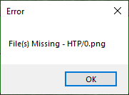You can receive an error: “File(s) Missing –HTP/x.png” where x is a number.  
  This error means that your HTP folder or the file(s) in the folder, is missing.  
  The HTP folder and the Blackjack.exe should be in the same folder.

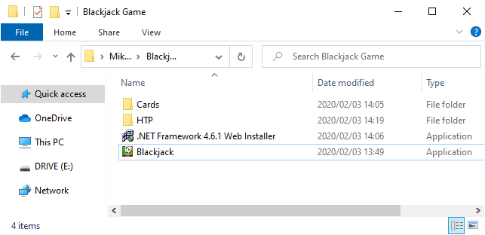

# Tutorial

## Starting the game:

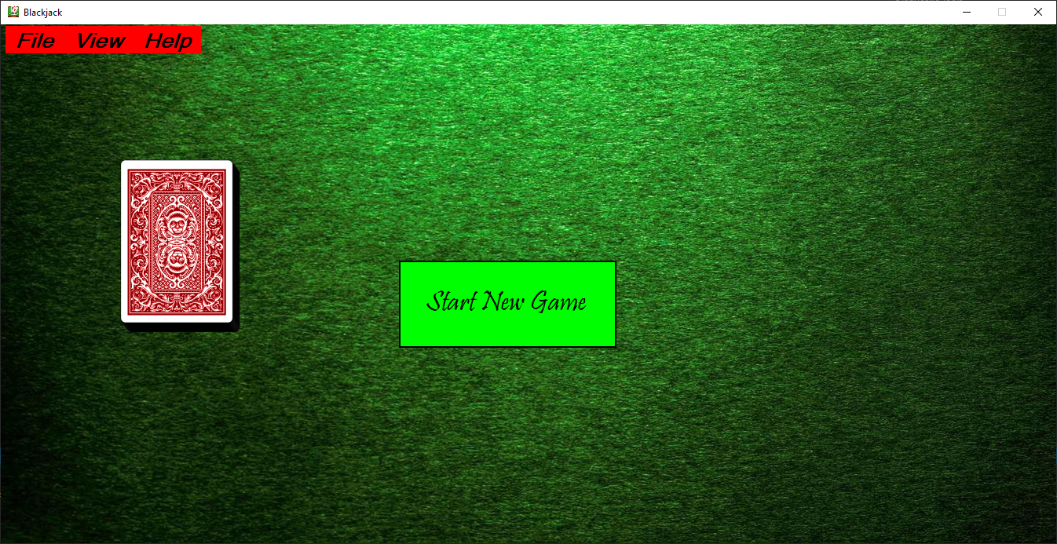To start a new game, click the “Start New Game” button.

## Playing the game (Part one):

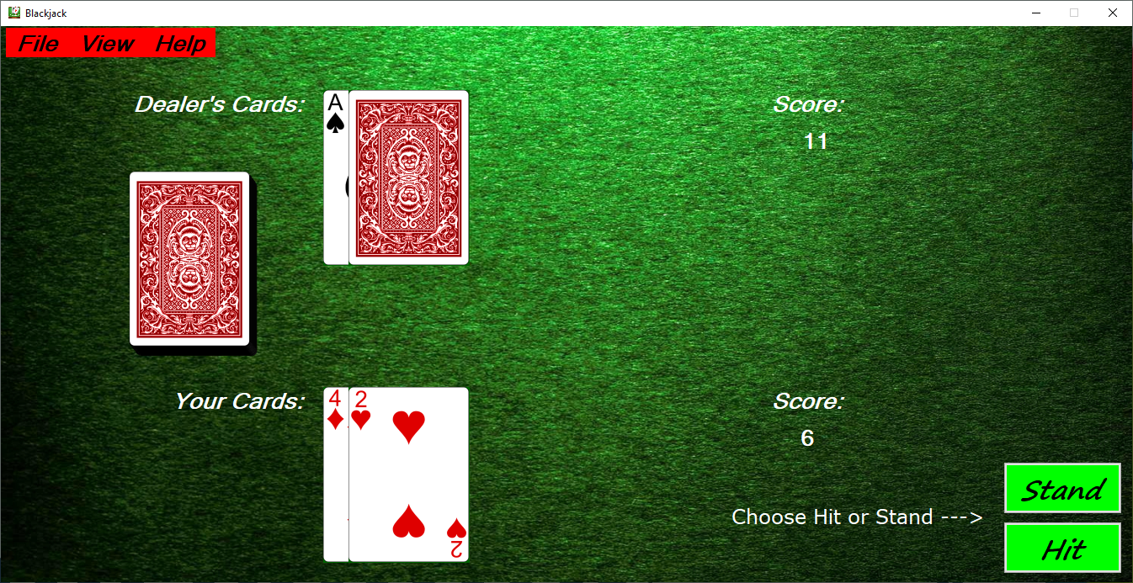You and the dealer each gets 2 cards. The dealer has 1 card face-up and 1 face-down. Both your cards are face up (visible).  
Your initial score is calculated. If this score is not 21, then you can choose to “Hit” or “Stand”.

## Playing the game (Part two):

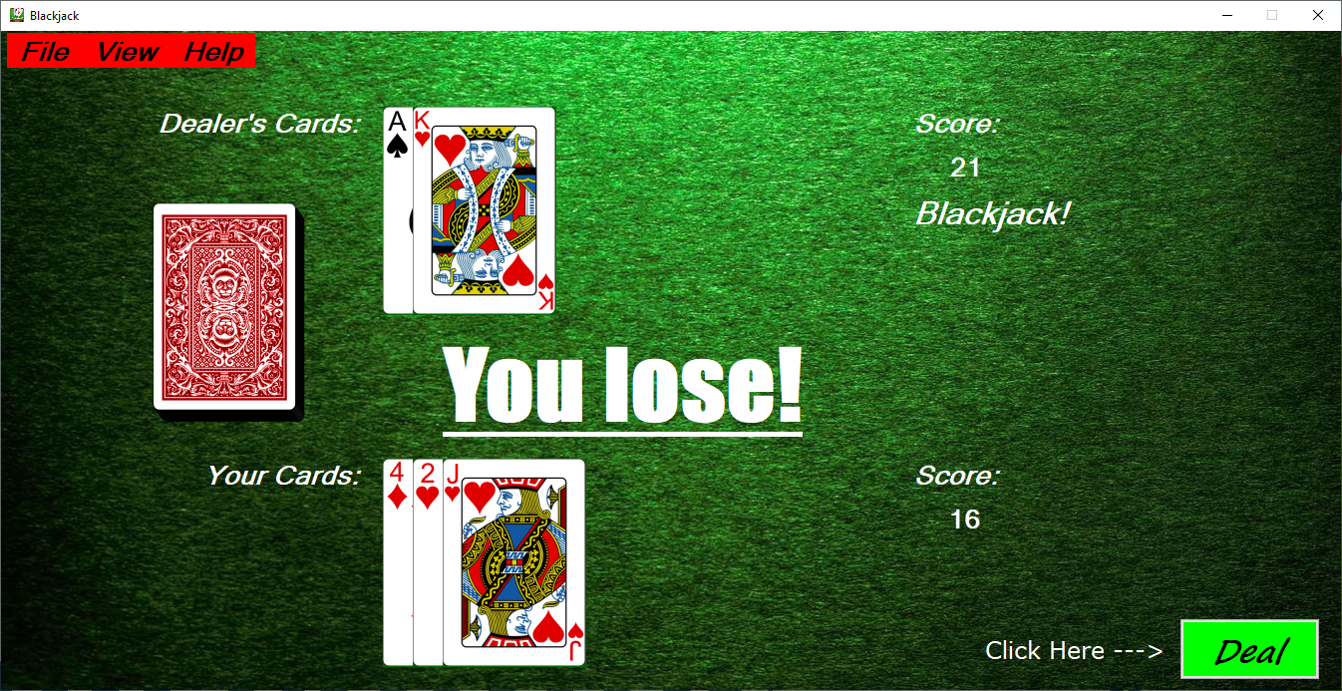If you hit, you will receive another card and your score will be recalculated. If you stand, you will keep the cards and score you currently have. You may choose to hit until you receive a blackjack, or your score goes over 21.  
Now it is the dealer’s turn to play. The dealer will reveal his second card. If the dealer’s score is below 17, he will hit. Otherwise, he will stand.  
After the dealer has finished his turn, the result (win, lose or tie) is displayed.

## Starting a new round:

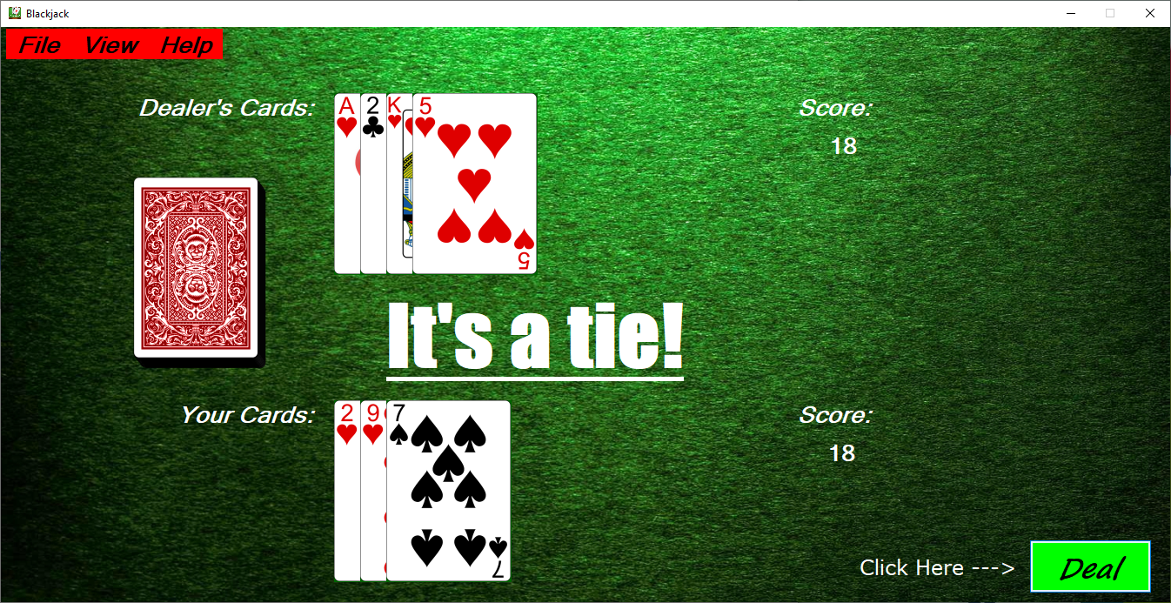Click the “Deal” button in the bottom right corner to start a new round.

## Scoreboard:

Click View – Scoreboard or “Alt + V, S” to show the scoreboard.

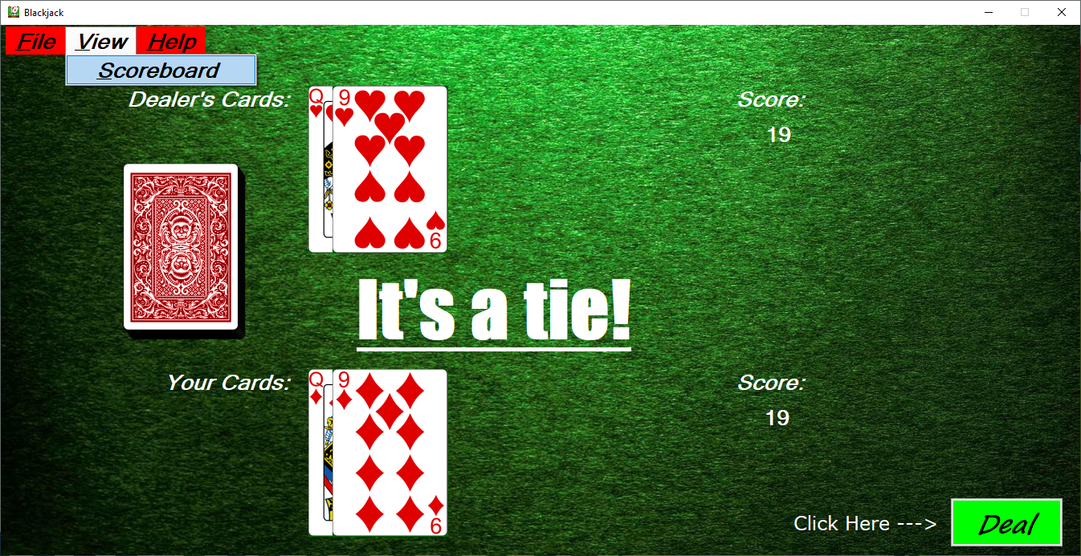

## Scoreboard:

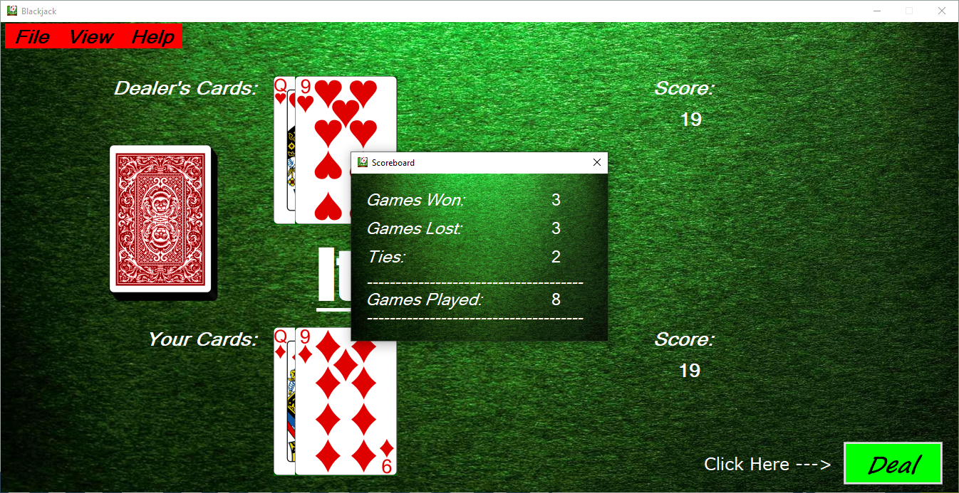Click X in the top right corner of the scoreboard, to close the scoreboard.

## Help:

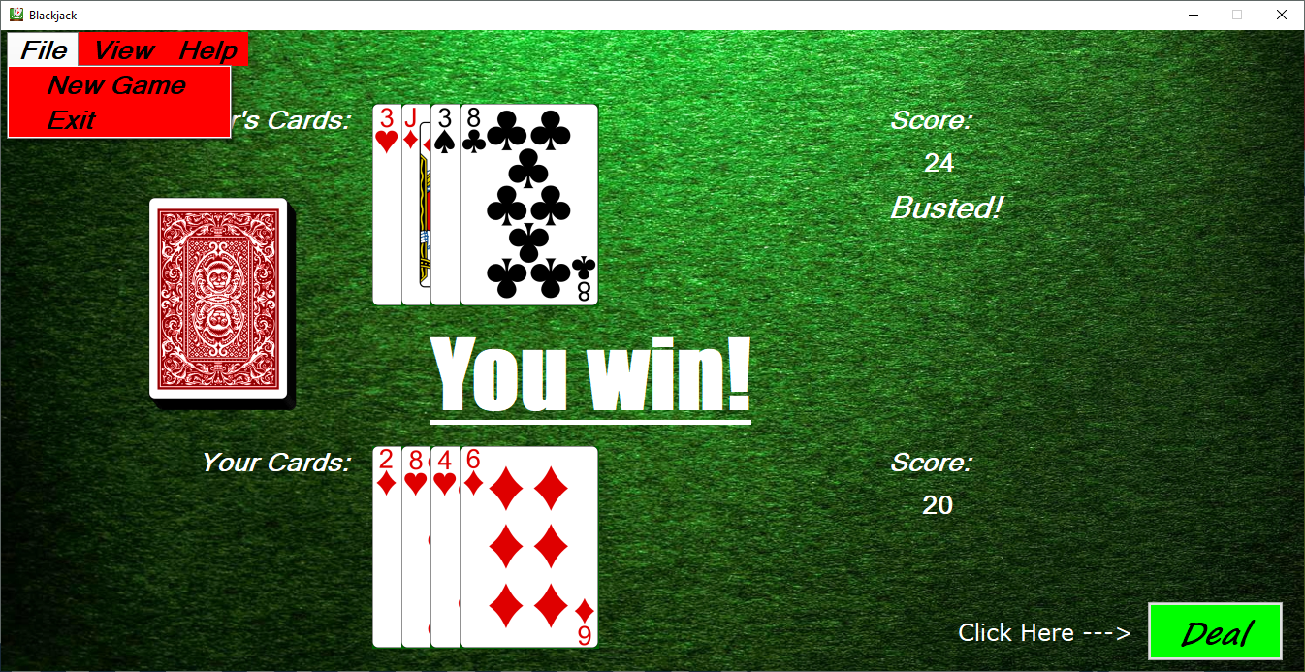Click Help – How to Play or “Alt + H, P” to view the tutorial again.

## Resetting or exiting the game:

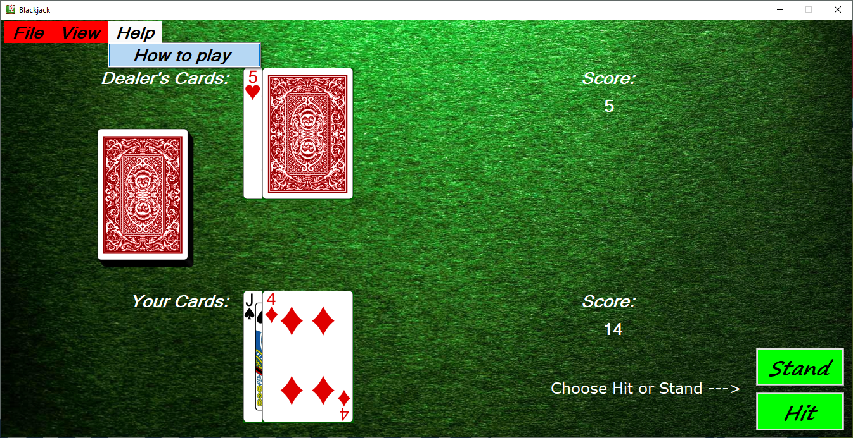Click File – New Game or “Alt + F, N” to start a new game, with the scoreboard reset.  
Click File – Exit or “Alt + F, E” or the X in the top right corner to close the game.

# Bibliography

* Basic C# Programming; BCSM-16; Compiled by: Kyle Brunette, Angelique Kolle, Lance Whyte, Cedric Maenetja, Daniel Sansom and Tatenda Tagutanazvo; Updated by: Suhayl H. Asmal; Edited by: Norman Baines; Version 1.0; © August 2015 CTI Education Group.
* <http://stackoverflow.com/>
* <https://msdn.microsoft.com/en-us/library/>
* <https://images.google.com/>